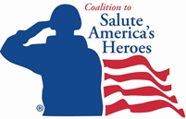
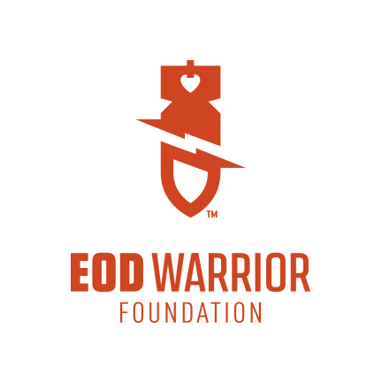
FOR IMMEDIATE RELEASE

Coalition to Salute America’s Heroes Awards $7500 Grant to the EOD Warrior Foundation to Help Build a Home for a Severely Wounded Veteran
The grant supports the Home for a Hero Community Campaign to build an accessible home for 12-year military veteran and Bronze Star Recipient Aaron Causey and his family

Leesburg, Va. The Coalition to Salute America’s Heroes, a leading not-for-profit organization dedicated to rebuilding the lives of severely wounded veterans of the War on Terror, has awarded a $7500 grant to the EOD Warrior Foundation for the Home for a Hero Community Campaign to build a home for Aaron Causey, a combat-wounded, 12-year military veteran and Bronze Star recipient, his wife Kathleen “Kat” and their 8-month old baby girl. The Coalition presented the grant to the Causeys and the EOD Warrior Foundation on Wednesday, September 10 in Leesburg, Va.

“Aaron and Kat Causey have overcome tremendous challenges as a result of his service to our nation and their resilience, courage and strength is truly remarkable,” said David Walker, president and CEO of the Coalition to Salute America's Heroes. “We are honored to award this grant to provide this needed financial support for the Causeys and we hope others in the community will donate to help them build their home.”

The EOD Warrior Foundation is helping to raise funds for the Home for a Hero Community Campaign that has a fundraising goal of $350,000 to build a safe and accessible modified home to meet Aaron’s extensive needs. There are currently no mortgage-free homes available through veteran-supporting programs for the Causeys to have an ADA-accessible home in the area of Birmingham, Alabama, where they are both from and will be returning to this fall.

Retired Sgt. 1st Class Aaron Causey sustained catastrophic injuries while serving as an Army Explosive Ordnance Disposal (EOD) technician in Afghanistan in September 2011. An improvised explosive device (IED) cost Aaron both of his legs and caused significant soft tissue damage. After more than 40 surgeries and two and a half years of recovery and rehabilitation as a patient of Walter Reed National Military Medical Center, Aaron and his family are finally ready to return home to Alabama, where they will have a network of support and assistance from their families and friends.

“Kat and I are very grateful to Coalition to Salute America’s Heroes for their generous support to help us build a home where I can be independent and able to live my everyday life more easily,” said Aaron Causey. “After three years of living in different, temporary housing that was so far from both of our families, we are looking forward to returning to our roots and raising our daughter in our own home.”

The EOD Warrior Foundation, that provides financial support and assistance to wounded EOD technicians and their families and honors fallen EOD warriors, has also awarded $7500 to the Home for a Hero Campaign. The many challenges and changes the Causeys face during Aaron’s long journey of recovery is chronicled in the award-winning documentary film The Next Part, which has been shown at such prestigious events as the Tribeca Film Festival, Nantucket Film Festival and the Sidewalk Film Festival in Birmingham.

For more information or to make a donation to the Home for a Hero Community Campaign, please go to http://weblink.donorperfect.com/Home4aHero.
(more)
Contacts:
Susanna Palmer, EOD Warrior Foundation
susanna@eodwarriorfoundation.org, 202-413-6251

David Walker, Coalition to Salute America’s Heroes
dwalker@saluteheroes.org, 703-291-4605

ABOUT THE EOD WARRIOR FOUNDATION
The EOD Warrior Foundation is a 501 (c)(3) nonprofit organization that honors fallen EOD warriors and provides financial assistance and support to wounded EOD warriors and families of fallen and wounded EOD warriors. The Foundation was formed through the March 1, 2013 merger of the EOD Memorial Foundation and the Wounded EOD Warrior Foundation. For more information about the EOD Warrior Foundation, please visit: www.eodwarriorfoundation.org.

ABOUT COALITION TO SALUTE AMERICA’S HEROES
The Coalition to Salute America’s Heroes, based in Leesburg, Virginia, has provided an invaluable, immediate lifeline to thousands of America’s wounded veterans since its establishment in 2004. The Coalition is distinguished from other veteran-focused organizations by its direct financial assistance to America’s wounded heroes. Its Emergency Financial Aid program has stopped foreclosure proceedings on veterans’ homes and kept their vehicles from being repossessed. The organization regularly provides gift checks to cover meals, medical and utility bills, clothing, car repairs and even baby diapers. To learn how you can support its mission, visit http://www.saluteheroes.org.

